# Sample Exam

1. Select the correct answer (1 point for each question)
   1. Which of the following running time is $O(n^{3})$: D

a). $n^{4}+n^{2}+1$ b). $n^{3}+1$

c). $2n^{2}+n+1$ d). Both b) and c)

e). Both a) and b)

* 1. Which of the following running time is $Ω(n^{3})$: E

a). $n^{4}+n^{2}+1$ b). $n^{3}+1$

c). $2n^{2}+n+1$ d). Both b) and c)

e). Both a) and b)

* 1. Consider the problem of sorting $N$ distinct positive integer numbers $a_{1},a_{2},⋯a_{N}$, what is the size of the input? C

a). b).

c). d).

* 1. Consider the following algorithm for testing whether a given number $x$ is prime: for all $2≤i≤x-1$, test whether $x$ is dividable by $i$, which statement is true? B

a). The algorithm runs in $O(x\log{x})$ time, and is a polynomial time algorithm

b). The algorithm runs in $O(x\log{x})$ time, and is a pseudo-polynomial time algorithm

c). The algorithm runs in $O(\log^{2}{x})$ time, and is a polynomial time algorithm

d). The algorithm runs in $O(\log^{2}{x})$ time, and is a pseudo-polynomial time algorithm

1.5 Which of the following statement is true: A

a). A stable matching always exists in a bipartite graph and the Gale-Shapley algorithm always finds one stable matching.

b). A stable matching does not necessarily exist in a bipartite graph, but if it exists, the Gale-Shapley algorithm always finds one stable matching.

c). A stable matching always exists in any graph. The Gale-Shapley algorithm always finds the stable matching.

d). A stable matching always exists in a bipartite graph. The Gale-Shapley algorithm does not necessarily find a stable matching.

1.6 Consider the following graph

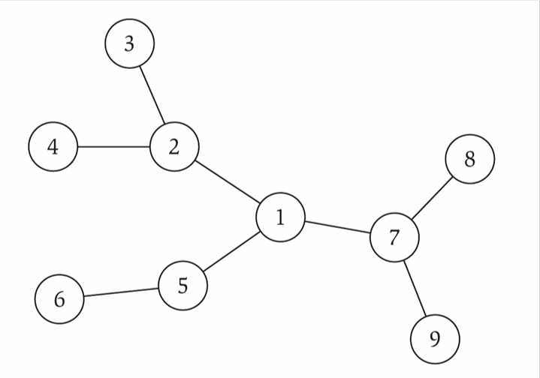

Which statement is true: A

a). This is a bipartite graph and also a tree

b). This is a bipartite graph but not a tree

c). This is a tree but not a bipartite graph

d). This is not a tree and not a bipartite graph

1.7 Which of the following statement is true: B

a). A bipartite graph can have both odd cycle and even cycle

b). A bipartite graph can have an even cycle but cannot have an odd cycle

c). A bipartite graph can have an odd cycle but cannot have an even cycle

d). A bipartite graph cannot have odd cycle nor even cycle

1.8 Consider the following graph and the cut

Which edge is in the cut set of $S$: C

a). $S$ is not a cut (not connected)

b). $(1,7)$

c). $(5,7)$

d). $(2,3)$

1.9 Which of the following statement is true: B

a). Any graph admits a spanning tree that consists all of its vertices

b). If a graph is connected, then it always admits a spanning tree that consists all of its vertices

c). If a graph has no cycle, then it always admits a spanning tree that consists all of its vertices

d). If a graph has more edges than vertices, then it always admits a spanning tree that consists all of its vertices

1.10 Which of the following statement is true: C

a). There exists an algorithm for multiplying two integers $a>b$ that runs in time $O(a)$, which is linear time in input.

b). There exists an algorithm for multiplying two integers $a>b$ that runs in time $O(a\log{a})$, which is near linear time in input.

c). There exists an algorithm for multiplying two integers $a>b$ that runs in time $O(\log{a}\log^{2}{\log{a}})$, which is nearly linear time in input.

d). Using FFT (fast fourier transform), it is impossible to have an algorithm for multiplying two integers $a>b$ that runs in time $O(a)$, because FFT requires $Ω(a)$ time.

1. (2 points) Is the following graph bipartite or not? State your reason.

1. (2 points) Find out a stable matching for the bipartite graph $\left\{A,B,C\right\}×\{X,Y,Z\}$ with the following preference list:

A: $X>Y>Z$

B: $Y>X>Z$

C: $X>Y>Z$

X: $B>A>C$

Y: $A>B>C$

Z: $A>B>C$

1. (2 points) Maximum spanning tree: Given is an edge-weighted connected graph $G$. The goal to find a spanning tree of the graph whose total edge weight is maximized. Give an algorithm for this problem.
2. (2 points) Consider a variant of knapsack problem where given is a set of $n$ items, with each item $j$ having a profit $p_{j}$, a length $l_{j}$ and a weight $w_{j}$. The goal is to find a subset of items such that their total length is at most $L$, total weight is at most $W$, and total profit is maximized. Design a dynamic programming algorithm for this problem that runs in $O(nWL)$ time.